Descriptive statistics
Name
Institution

- Manual Calculations
- Measures of central tendency
x | f | fx
4 | 2 | 8
5 | 3 | 15
6 | 7 | 42
7 | 8 | 56
8 | 12 | 96
9 | 7 | 63
10 | 1 | 10
 | $\sum{f}=$40 | $\sum{fx}=$290

Mean ( $\overline{x})=$ $\frac{\sum{fx}}{\sum{f}}$
=290/40
=7.25
The average amount of sleep per night for all college students is 7.25 hours.
Mode
The modal value is the most occurring. Based on the data in the table above, the hours of sleep most reported by the students are 8 hours reported by the highest number of college students (n=12 students).
Median
The median value is obtained by first arranging the data in ascending order and then taking the median value of the distribution.

4 |  |  | 8
4 |  |  | 8
5 |  |  | 8
5 |  |  | 8
5 |  |  | 8
6 |  |  | 8
6 |  |  | 8
6 |  |  | 8
6 |  |  | 8
6 |  |  | 8
6 |  | mid values | 8
6 |  | 7 | 9
7 |  | 8 | 9
7 |  |  | 9
7 |  |  | 9
7 |  |  | 9
7 |  |  | 9
7 |  |  | 9
7 |  |  | 10
The middle values of these data are:
20th value= 7
21st value=8
Median= (7+8)/2
= 7.50
In this line, at least 50% of college students reported 7 or more hours of sleep.
- Measures of dispersion
Variance
Variance=$\frac{\sum{f{(x-\overline{x})}^{2}}}{n-1}$
x | f | fx | x-7.25 | (x-7.25)^2 | f(x-7.25)^2
4 | 2 | 8 | -3.25 | 10.5625 | 21.125
5 | 3 | 15 | -2.25 | 5.0625 | 15.1875
6 | 7 | 42 | -1.25 | 1.5625 | 10.9375
7 | 8 | 56 | -0.25 | 0.0625 | 0.5
8 | 12 | 96 | 0.75 | 0.5625 | 6.75
9 | 7 | 63 | 1.75 | 3.0625 | 21.4375
10 | 1 | 10 | 2.75 | 7.5625 | 7.5625
 | $\sum{f}=$40 | $\sum{f}x=$290 |  |  | $\sum{f}{(x-\overline{x})}^{2}=$83.5

Variance=83.5/40-1
=83.5/39
=2.14
The variance of the data is 2.14
Standard deviation=sqrt(2.14)
=1.46
The standard deviation is 1.46 suggesting a minimal variation in the sleep hours recorded amongst the sampled students. The sleep hours vary by 1.46.
Range
Range=Maximum value – Minimum value
=10-4
=6.00
The difference between the highest and lowest sleep hours of the college students is 6 hours.
- A sketched bar chart of the data by hand

- Descriptive Statistics in SPSS
The objective of this analysis was to describe the distribution of the number of hours of sleep reported by students in college. The data were collected from a sample of forty students (n=40). The SPSS analysis platform was used to generate measures of central tendency (mean, mode, median), measures of dispersion (range, standard deviation, and variance), as well as a bar chart and a histogram.
The mean, median, and mode were 7.25, 7.50, and 8, respectively (see Table 1). The differences among the number of hours of sleep suggest a somewhat negatively skewed distribution (negatively skewed distribution), with about 50% of the sampled college students reporting about 7 or more hours of sleep per night. The observation of non-normality conforms with the standard deviation of the data, which was observed at 1.46 sleep hours. The bar chart (see Figure 1) and the histogram (see Figure 2) both conform with the idea of the negatively skewed distribution. The coefficient of skewness was -0.4, which conforms with the observation of negative skewness.
Conclusively, the distribution of these data can be grouped into those students who reported less than 8 hours of sleep and those that reported more than 8 hours of sleep. About 30% (n=12 students) reported having 8 hours of sleep, whereas 5% (n=2 students) reporting 4 hours of sleep. Individuals with 10 hours of sleep appear as an outlier in the dataset as only 1 student reported sleeping for that long (see Table 2).
Table 1: Number of Hours of Sleep Reported by College Students
N | Valid | 40
N | Missing | 0
Mean |  | 7.25
Median |  | 7.50
Mode |  | 8
Std. Deviation |  | 1.463
Variance |  | 2.141
Skewness |  | -.459
Std. Error of Skewness |  | .374
Range |  | 6

Table 2: Number of Hours of Sleep Reported by College Students
 |  | Frequency | Percent | Valid Percent | Cumulative Percent
Valid | 4 | 2 | 5.0 | 5.0 | 5.0
Valid | 5 | 3 | 7.5 | 7.5 | 12.5
Valid | 6 | 7 | 17.5 | 17.5 | 30.0
Valid | 7 | 8 | 20.0 | 20.0 | 50.0
Valid | 8 | 12 | 30.0 | 30.0 | 80.0
Valid | 9 | 7 | 17.5 | 17.5 | 97.5
Valid | 10 | 1 | 2.5 | 2.5 | 100.0
Valid | Total | 40 | 100.0 | 100.0

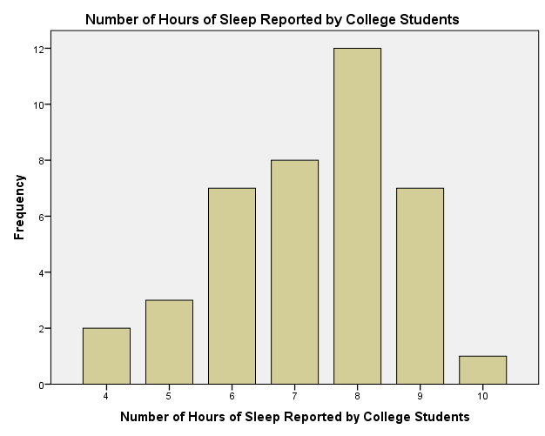
Figure 1: A bar chart of the number of hours of sleep reported by college students.

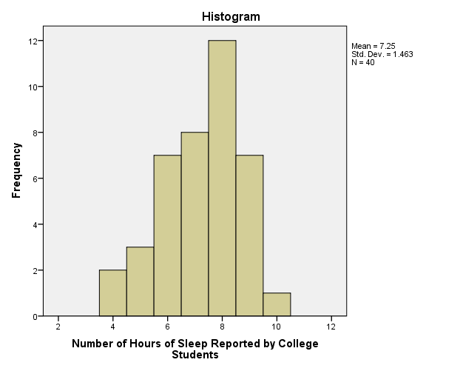
Figure 2: A histogram of the distribution of the number of hours of sleep reported by college students.

